Riphah International University

Gulberg greens Campus

Submitted by : Mahnoor Ahmed
Sap id : 80207
Submitted to : Mam Nayab Khalid
Lab # 03

Task no.1
Student Information
Create a Student class with private name and age variables. Use setters to assign values and getters to display them. Take name and age from the user using Scanner.
Requirements:
- ﻿﻿Use private instance variables: name and age.
- ﻿﻿Create setName(), setAge), getName), and getAge).
- ﻿﻿Use this in the setter methods.
- ﻿﻿Take input in main().
- ﻿﻿Display the data using getters.

Program:
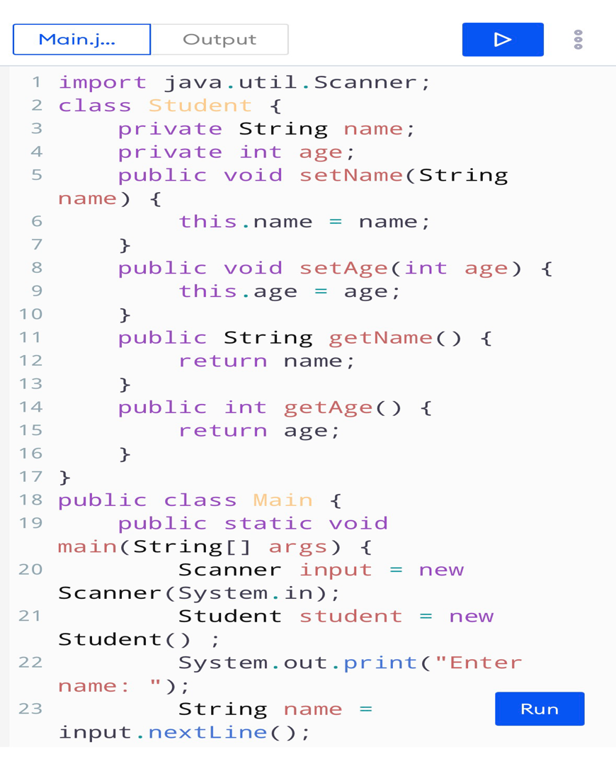
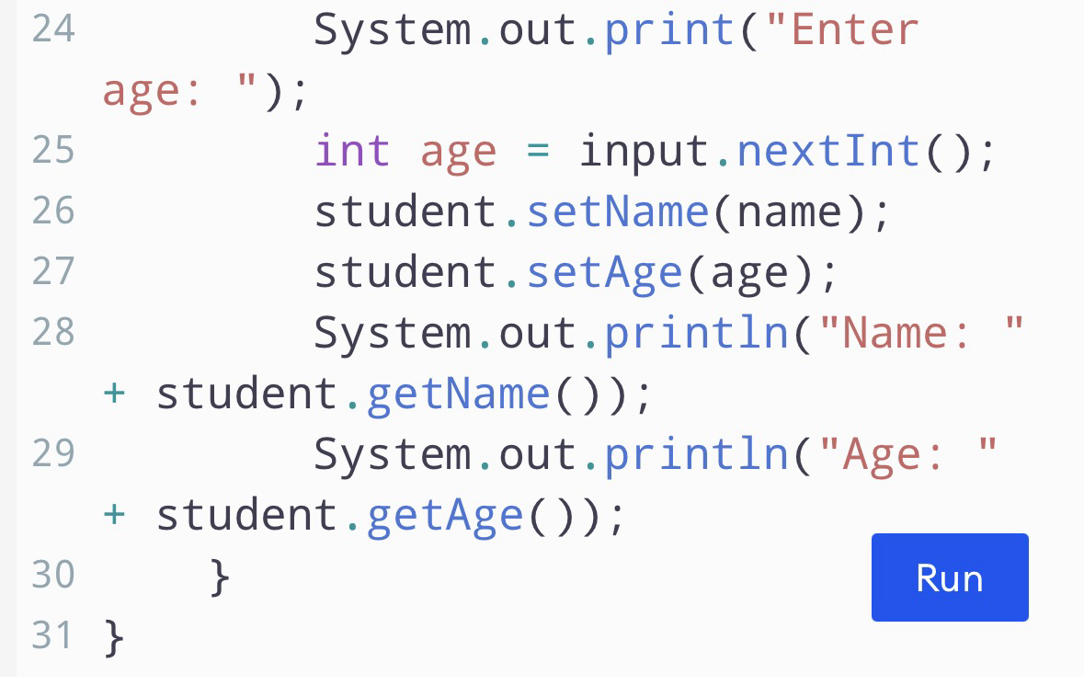
Result:
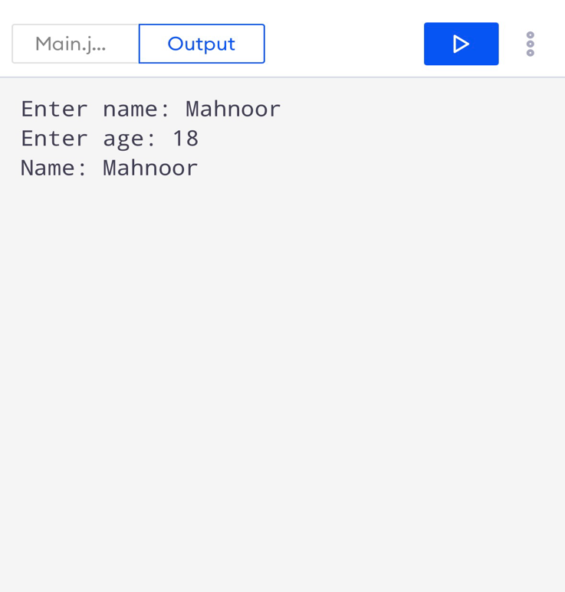

Task no.2
Create a Product class with name, price, and quantity as private instance variables and totalProducts as a static variable.
- ﻿﻿Create setters and getters for name, price, and quantity.
- ﻿﻿Use this in all setters.
- ﻿﻿Create two Product objects.
- ﻿﻿Increase totalProducts whenever a product object is created or registered.
- ﻿﻿Display both products and the total number of products.

Program :
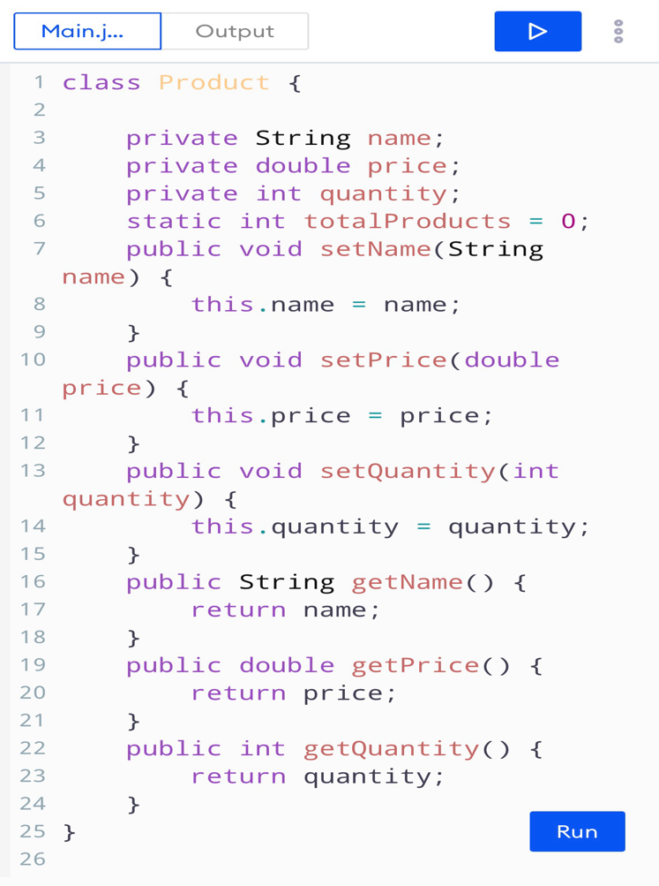
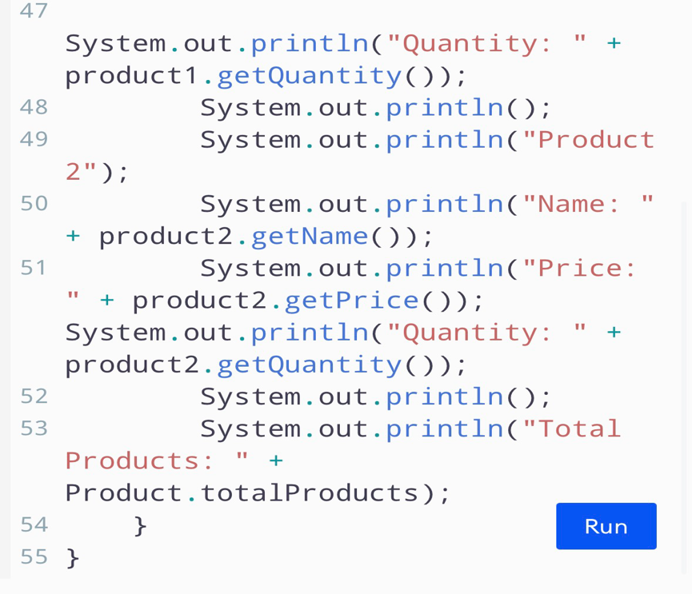
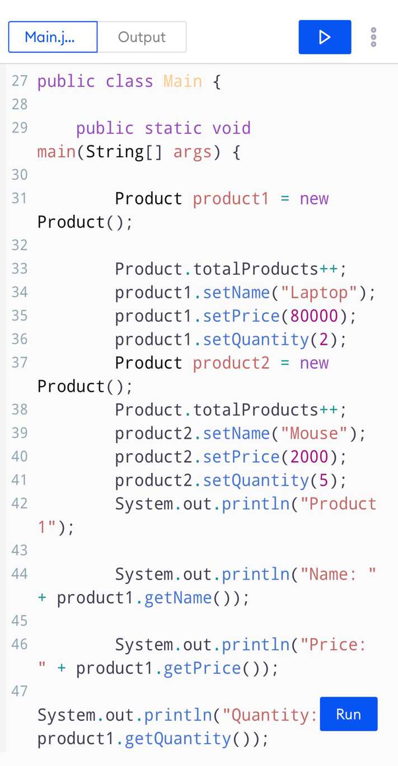

Result:
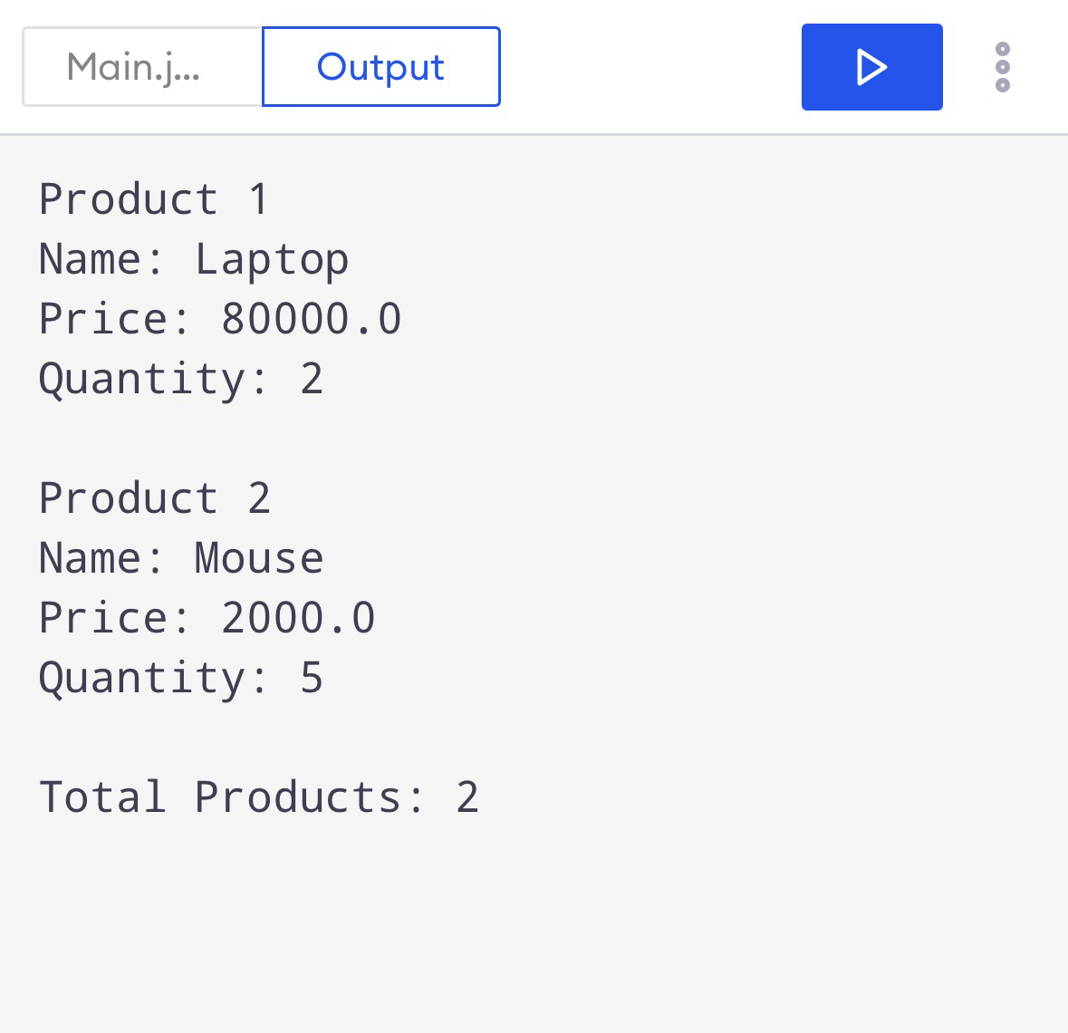

Task no .3
- Bank Account
Create a BankAccount class with accountHolder, accountNumber, and balance as private instance variables. Use getters and setters. Add a static totalAccounts variable.
- ﻿﻿Take input for two bank accounts using Scanner.
- ﻿﻿Set all values through setters.
- ﻿﻿Display values through getters.
- ﻿﻿Use a setter to prevent a negative balance.
- ﻿﻿Display totalAccounts using the class name.
Program:
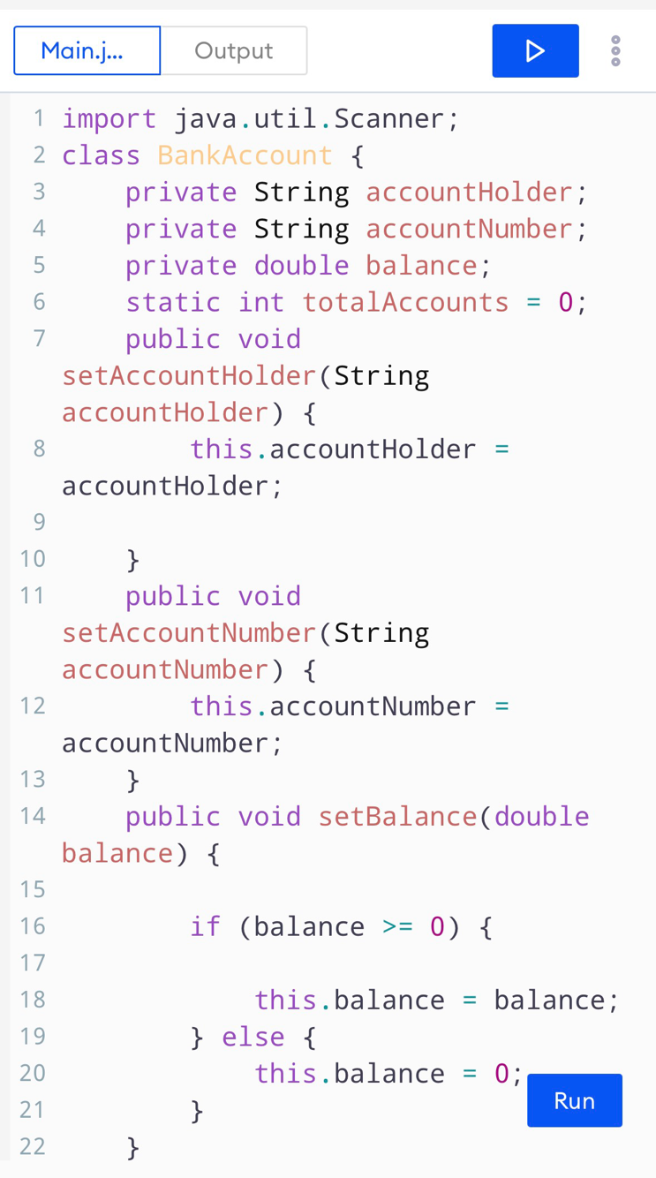
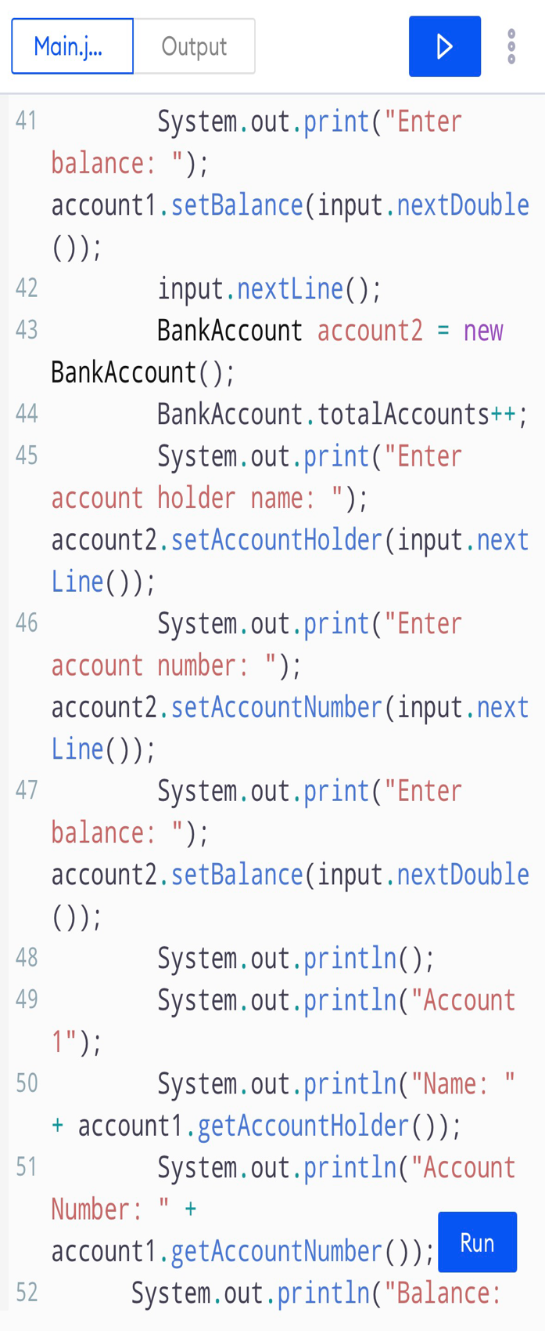
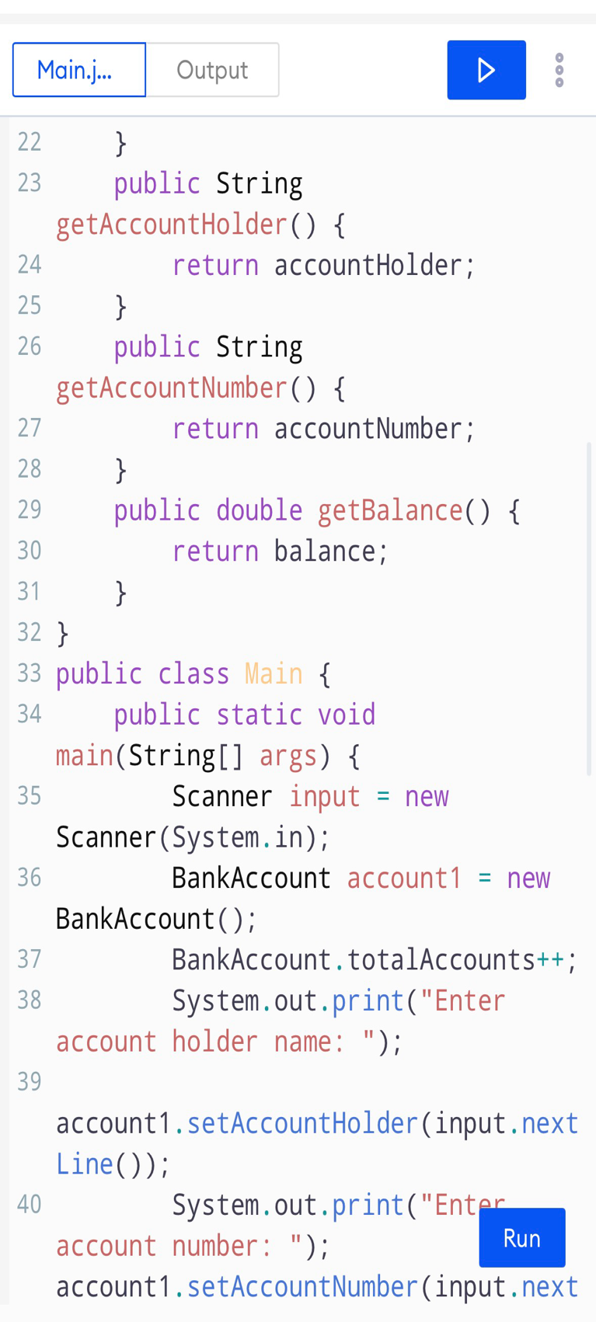

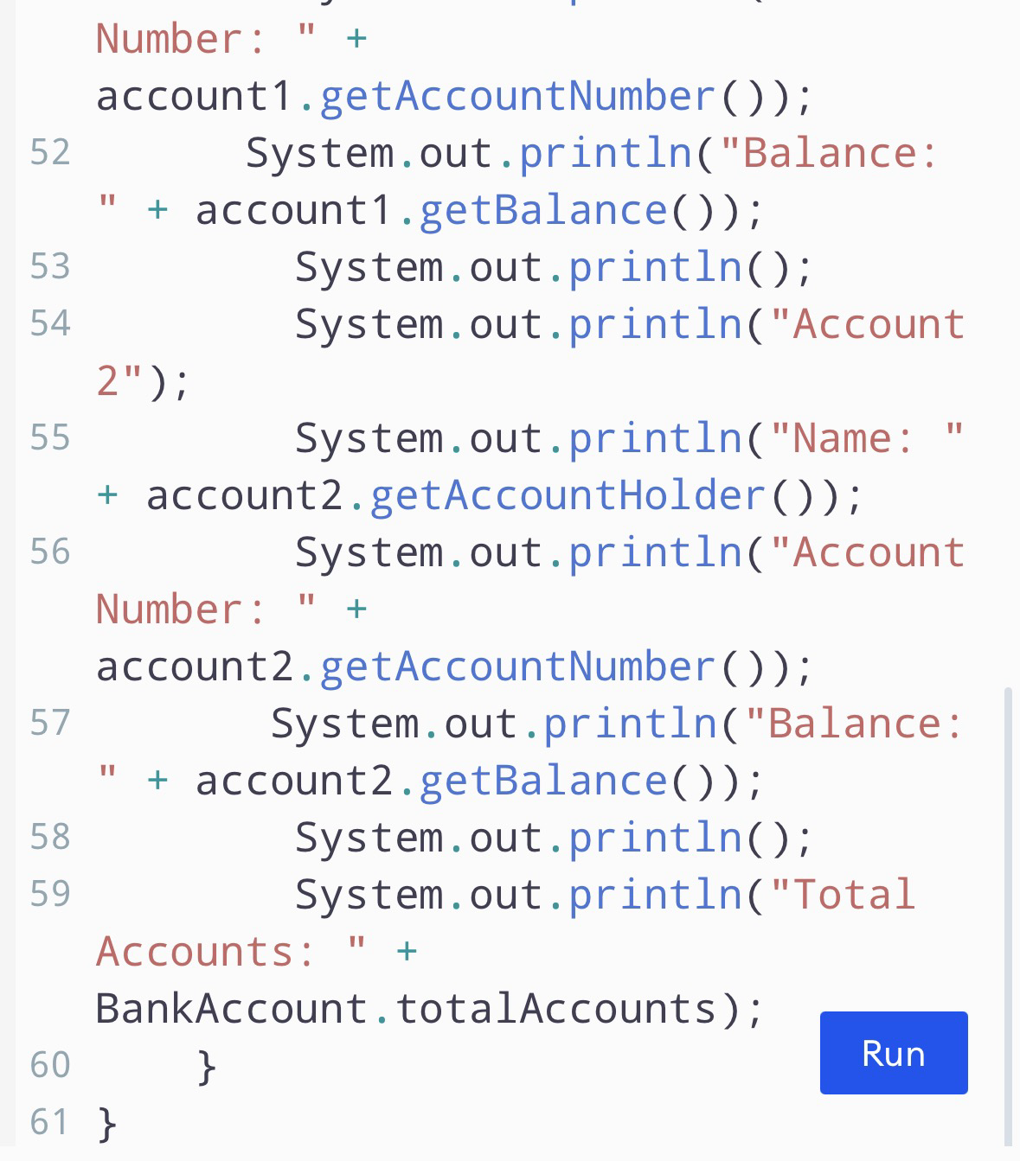
Result:


